# Milestone 1 submission

**Team name**

FlatDyn Games

**Proposed Level of Achievement:**

Apollo 11

**Motivation**

Nowadays, the game industry is developing rapidly. Its influence cannot be ignored. Video games are no longer just for entertainment, and the technology in this field can even be applied to other fields such as movies, medical care, driverless driving, and urban planning.

As one of the traditional game concepts, 2D platform jumping game has countless masterpieces, such as "Ori and the will of the wisps" and "Dead Cells". We have decided to develop a game of this type as the first step in exploring the game development techniques.

**Scope**

Edge of Adventure is a single-player 2D platform jumping game set in a fictional world.

Players will experience interesting combat systems and diverse enemy modes of action.

Players can gain experience points and collect various props during the adventure.

The complete storyline and beginner guide will navigate players to enjoy the whole world outlook and learn how to control the character.

**User stories**

1. Smooth program operation.

2. Control the character to complete movements, attacks, and other commands.

3. Switch between different screens such as the main menu and settings, and freely select levels.

4. Experience the full game visuals and sound effects.

5. Have fun and enjoy the game.

**Core features(proposed)**

Edge of Adventure will be a 2D platform jumping game which focus on the combat system. We will make the animations look smooth, with natural transitions between each action. The character controlled by players will have various of skills. Players can combine different skills to form combos. Additionally, the character will have some defense measures to deal with the enemy, such as block or evasion. It depends on players to destroy the enemy with stormy attacks or expose their weaknesses with targeted defense.

**Tech stacks(current)**

Unity

- The game engine that our game runs on

C#

- The language used to code in Unity

Adobe Animate

- The sprite maker

**Design and plan**

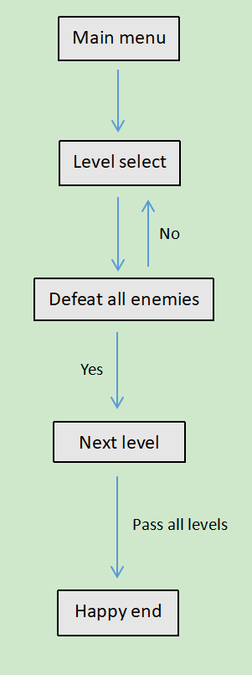Game flow diagram

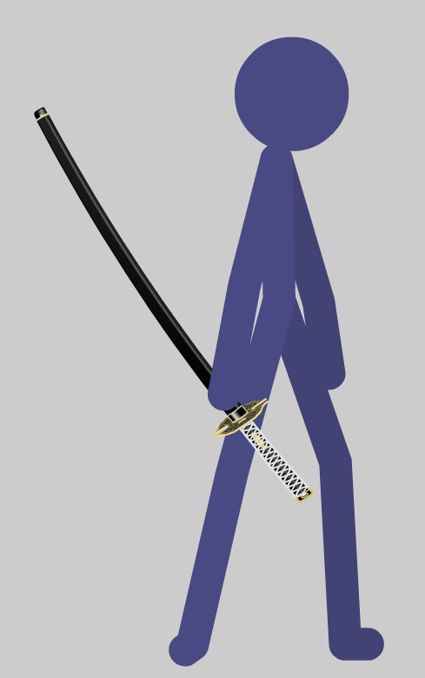Hero

**Project log**

**Project poster**

**Project video**